SIMATS ENGINEERING

ASSESSMENT TOOL 1

COURSE NAME: CSA16 COURSE CODE: Data Warehousing and Data Mining

COURSE OUTCOME COVERED
CO5: Apply association rule mining techniques to discover interesting relationships and patterns within large datasets
Assessment Tool Weightage: 35%

QUESTIONS: 05 Total Marks:50
Annexure A
Constraint-Based Problem Solving

Criteria | Problem Understanding (2.5) | Constraint Analysis (2.5) | Solution Development (2.5) | Application of Concepts (1.5) | Justification  (1) | Total(10)
Weightage | 25% | 25% | 25% | 15% | 10% | 100%
Q1
Q2
Q3
Q4
Q5

Code of Conduct:

I V. Pavan Kumar Reddy (192472109) (Name / Reg No) certify that this submission is my original work and that I have adhered to the guidelines specified for this assessment.
I understand that any violation of academic integrity rules will result in disciplinary action.

Signature of the student: pava

RUBRICS FOR CALCULATION:

Constraint-Based Problem Solving Assessment Rubric
Criteria | Weightage | Level 4 (Exemplary) | Level 3 (Proficient) | Level 2 (Developing) | Level 1 (Beginning)
Problem Understanding | 25% | Clearly defines the problem and identifies all relevant constraints  accurately | Identifies most constraints with minor gaps | Partial understanding; misses key constraints | Fails to identify constraints correctly
Constraint Analysis | 25% | Analyzes constraints effectively and prioritizes them  logically | Provides reasonable analysis with some prioritization | Limited analysis; weak prioritization | No meaningful analysis or prioritization
Solution Development | 25% | Develops optimal and feasible solutions satisfying all  constraints | Develops workable solutions with minor limitations | Solutions partially satisfy constraints | Solutions do not meet constraints
Application of Concepts | 15% | Effectively applies appropriate concepts,  methods, or tools | Applies concepts with minor errors | Limited application; requires guidance | Unable to apply relevant concepts
Justification | 10% | Provides strong justification for decisions with logical  reasoning | Provides justification with some clarity | Weak or unclear justification | No justification provided

Annexure A

Constraint-Based Problem Solving (6 Marks) (BL4–BL5) – Reframed with New Scenarios
Q1. Dataset: Hospital Patient Records

PID Symptoms Observed
P1 Fever, Cough P2 Fever, Headache
P3 Cough, Headache
P4 Fever, Cough, Headache P5 Fever, Fatigue

Question:
Apply association rule mining with minimum support = 50% and confidence = 70%, under the constraint that all generated rules must include "Fever". Identify the valid association rules and justify why they satisfy the given constraints. (BL4 – 1.2 Marks)

Q2. Dataset: Online Learning Platform

Student ID Courses Enrolled
S1 Python, SQL
S2 Python, Data Science
S3 SQL, Machine Learning
S4 Python, SQL, Data Science
S5 Python, Machine Learning

Question:
Using the dataset, generate frequent itemsets with minimum support = 40%, applying the constraint that each itemset must contain at least two courses. Explain how the constraint helps in pruning candidate itemsets during mining. (BL4 – 1.2 Marks)

Q3. Dataset: Library Borrowing Records

Transaction ID Books Borrowed
T1 Data Mining, Python Programming
T2 Data Mining, Database Systems
T3 Python Programming, Database Systems
T4 Data Mining, Python Programming, Database Systems T5 Data Mining, Artificial Intelligence

Question:
Apply the Apriori algorithm with the constraint that the maximum itemset size is 3. Identify the frequent itemsets and explain how the constraint reduces computational complexity during candidate generation.

Q4. Dataset: University Course Hierarchy

Student ID Courses Taken
S1 Engineering, Computer Science, Machine Learning S2 Engineering, Information Technology
S3 Engineering, Computer Science
S4 Engineering, Computer Science, Machine Learning S5 Engineering, Information Technology

Question:
Apply multilevel association rule mining with the constraint that rules should be generated only at the "Computer Science" level. Explain how the course hierarchy affects the discovery of association rules. (BL5 – 1.2 Marks)

Q5. Dataset: Insurance Customer Records

CID Age Group Income Level Policy Purchased

C1 | Young | High | Health Insurance
C2 | Middle | Medium | Vehicle Insurance
C3 | Young | Low | Travel Insurance
C4 | Senior | High | Health Insurance
C5 | Young | Medium | Vehicle Insurance

Question:
Apply multidimensional association rule mining with the constraint Age Group = "Young". Identify meaningful patterns involving income level and policy type, and explain how these patterns can support targeted marketing strategies. (BL4 – 1.2 Marks)

Q1. Hospital Patient Records — Association Rule Mining

Transactions: 5
Minimum support = 50% → at least 3 transactions Minimum confidence = 70%
Constraint: Every rule must include Fever. Step 1: Frequent itemsets
Itemset | Count | Support
Fever | 4 | 80%
Cough | 3 | 60%
Headache | 3 | 60%
Fever, Cough | 2 | 40%
Fever, Headache | 2 | 40%

The combinations containing Fever do not reach the required 50% support.

Therefore, no non-trivial association rule containing Fever satisfies both support ≥ 50% and confidence ≥ 70%.

For example:

- Fever → Cough
Support = 2/5 = 40% → fails support.
- Cough → Fever
Support = 2/5 = 40% → fails support.
- Fever → Headache
Support = 2/5 = 40% → fails support.
- Headache → Fever
Support = 2/5 = 40% → fails support.

Answer:

No valid non-trivial association rules can be generated under the given constraints.

The constraint requiring Fever further prunes all candidate rules that do not contain Fever, while the 50% support threshold eliminates the Fever-containing pairs.

Output:
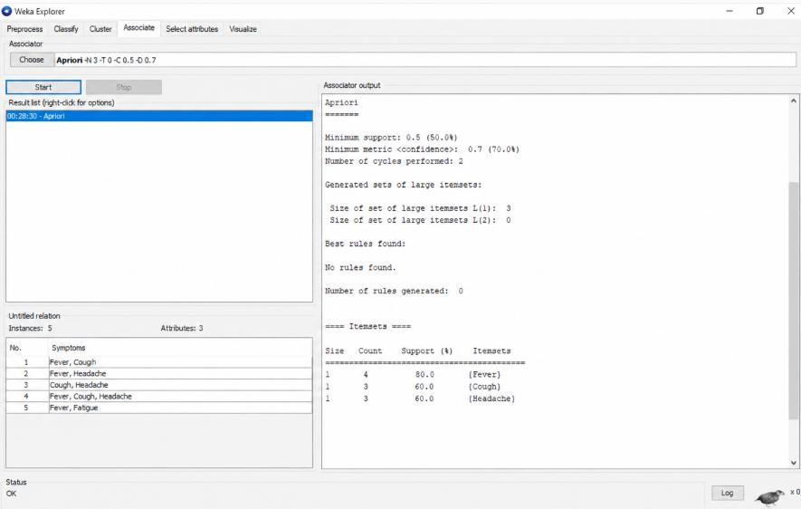

Q2. Online Learning Platform — Frequent Itemsets Transactions = 5
Minimum support = 40%

Therefore, an itemset must occur in at least:

5 × 40% = 2

transactions.

Constraint: Itemset must contain at least 2 courses. 2-itemsets

Itemset Count Support Valid?

Python, SQL | 2 | 40% | ✓
Python, Data Science | 2 | 40% | ✓
Python, Machine Learning | 1 | 20% | ✗
SQL, Machine Learning | 1 | 20% | ✗

Itemset Count Support Valid?
SQL, Data Science 1 20% ✗
Data Science, Machine Learning 0 0% ✗

3-itemset

Itemset Count Support
Python, SQL, Data Science 1 20% So it is not frequent.

Answer:

The frequent itemsets satisfying support ≥ 40% and size ≥ 2 are:

{Python, SQL} — 40%
- {Python, Data Science} — 40% How the constraint helps pruning
The minimum-size constraint eliminates all 1-itemsets immediately. Hence, the algorithm starts candidate generation from 2-itemsets, reducing the number of candidates and the computational effort required for support counting.

OUTPUT:
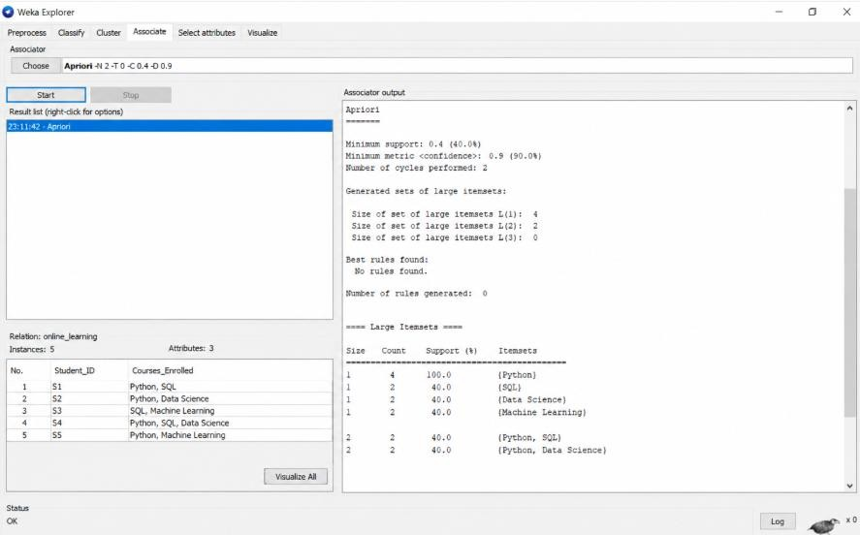

Q3. Library Borrowing Records — Apriori Transactions = 5
Maximum itemset size = 3.

Since no minimum support is explicitly stated, we can use the same 50% threshold implied by the dataset-style question, i.e., an itemset must occur at least 3 times.

1-itemsets
Item Count | Support
Data Mining 4 | 80%
Python Programming 3 | 60%
Database Systems 3 | 60%
Artificial Intelligence 1 | 20%
Frequent 1-itemsets:

{Data Mining}, {Python Programming}, {Database Systems} 2-itemsets
Itemset Count Support
Data Mining, Python Programming 2 40%
Data Mining, Database Systems 2 40%
Python Programming, Database Systems 2 40%

None reaches 50%.

Therefore, no frequent 2-itemsets are available.

Consequently, no frequent 3-itemset can be generated using Apriori's pruning property.

Answer:

Frequent itemsets are:

- {Data Mining} — 80%
- {Python Programming} — 60%
- {Database Systems} — 60%

The maximum-size constraint of 3 prevents generation of itemsets larger than three items. This reduces candidate generation and support-counting operations.

Note: The question does not explicitly provide minimum support. If your instructor intended a different threshold, the frequent 2- and 3-itemsets will change accordingly.

OUTPUT
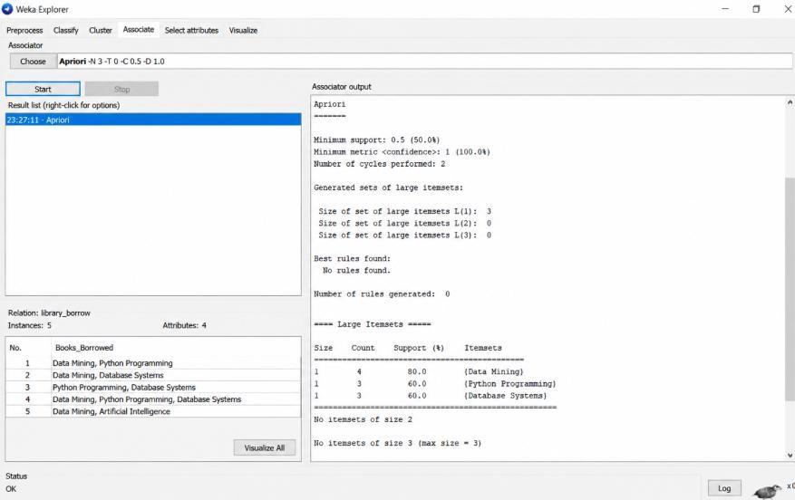

Q4. University Course Hierarchy — Multilevel Association Rule Mining Constraint: Rules should be generated only at the Computer Science level. Transactions containing Computer Science:
- S1 → Engineering, Computer Science, Machine Learning
- S3 → Engineering, Computer Science
- S4 → Engineering, Computer Science, Machine Learning Thus:
Computer Science = 3/5 = 60%

Among these three Computer Science transactions:

- Machine Learning occurs in S1 and S4 → 2/3 = 66.7%
- Engineering occurs in all three → 3/3 = 100% Therefore, the meaningful association at the requested level is: Computer Science → Engineering
Support:

3
× 100 = 60%
5

Confidence:
𝑆𝑢𝑝𝑝𝑜𝑟𝑡(𝐶, 𝑆𝐸𝑛𝑔𝑖𝑛𝑒𝑒𝑟𝑖𝑛𝑔) 60%
𝑆𝑢𝑝𝑝𝑜𝑟𝑡(𝐶𝑆) = 60% = 100%

Another possible pattern is:

Computer Science → Machine Learning

Support:
2
= 40%
5

Confidence:

2/5

3/5
= 66.7%

Answer:

At the Computer Science level, the strongest pattern is:

Computer Science → Engineering

with 60% support and 100% confidence.

The hierarchy allows mining at a specific abstraction level rather than mixing rules from all course categories. Restricting the mining to the Computer Science level reduces irrelevant candidate rules and produces more focused relationships.

Output:

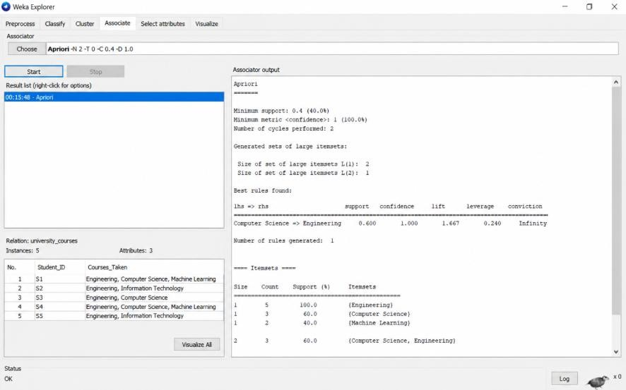

Q5. Insurance Customer Records — Multidimensional Association Rule Mining Constraint: Age Group = Young
Young customers:

Customer Age Income Policy
C1 Young High Health Insurance C3 Young Low Travel Insurance C5 Young Medium Vehicle Insurance
There are 3 Young customers. Income patterns
Each income category occurs once:

- Young + High → Health Insurance = 1/3 = 33.3%
- Young + Low → Travel Insurance = 1/3 = 33.3%
- Young + Medium → Vehicle Insurance = 1/3 = 33.3% Meaningful patterns
- Young + High Income → Health Insurance
  - Support = 1/5 = 20%

  - Within Young customers = 1/3 = 33.3%
- Young + Low Income → Travel Insurance
  - Support = 1/5 = 20%
  - Within Young customers = 1/3 = 33.3%
- Young + Medium Income → Vehicle Insurance
  - Support = 1/5 = 20%
  - Within Young customers = 1/3 = 33.3% Marketing application
These patterns can help insurers create age- and income-specific campaigns:

- Young + High income: promote Health Insurance.
- Young + Medium income: promote Vehicle Insurance.
- Young + Low income: promote affordable Travel Insurance.

Because the dataset has only 5 customers, these patterns should be treated as preliminary rather than strong general-market conclusions.

Output:

